Use-Case Realization Report
UpdateUser

Issue <1.0>
Revision History
Date | Issue | Description | Author
<02/08/09> | <1.0> | <Update User> | <Karen Gao>

Table of Contents
1. Brief Description 4
2. Flow of Events 4
2.1 Standard Flow 4
2.2 Exceptions 4
3. Interaction Diagrams 5
3.1 Collaboration Diagram for UpdateUser 5
4. Participating Objects 5
5. Class Diagrams 6
5.1 Class Diagram for UpdateUser 6
6. Derived Requirements 6

Use-Case Realization Report
UpdateUser

Brief Description
The update of User shall be executed once the check for the selection of the existing User list and validation of updates were performed.

Flow of Events

Standard Flow
This use case covers the events of updating User, which is part of the Maintenance User package. The standard flow of events is described as below:
- The User Administrator shall press the button to send out a command of “updateButtonClicked” on the interface of MaintainUserPage.
- Once UserController received this request, the operation checkUserToUpdate will check if there’s User selected.
- Then the operation getRole will get the Role from object of Role, and show to the MaintainUserPage through the operation displayUser.
- The User Administrator shall press the button of updateSaved to User Controller, and it will check for the validation of updates.
- Subsequently, role will be re-assigned to the user through the operation reassignRole of User Controller. The operation updateUserList will sent the updated User in the User List from object of User.
- Once it’s done, the successful updating User will show to the MaintainUserPage through the operation showUserList.

Exceptions

- If there’s no selection found in User records, a warning message will be show to the MaintainUserPage through the operation showNoUserSelectedMsg.
- If there’s invalidation found, a warning message will be show to MaintainUserPage through the operation showUpdatesInvalidMsg

Interaction Diagrams

Collaboration Diagram for UpdateUser
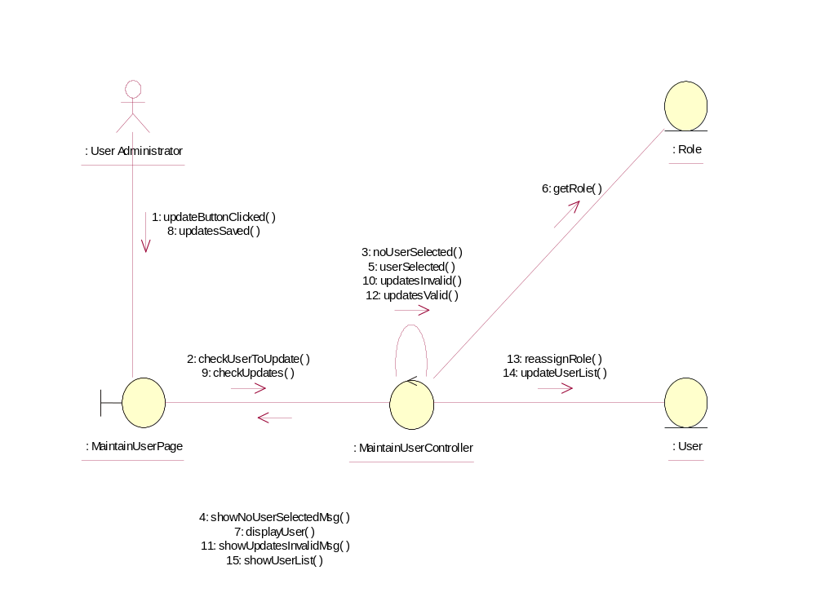

Participating Objects
: MaintainUserController
This controller is to add, delete and update User Admin

: MaintainUserPage
This is a page for adding, deleting, updating and displaying User Admin

: Role
This Entity is Role object

: User
This Entity is User Admin object

: User Administrator
This is the super user of the system

Class Diagrams

Class Diagram for UpdateUser
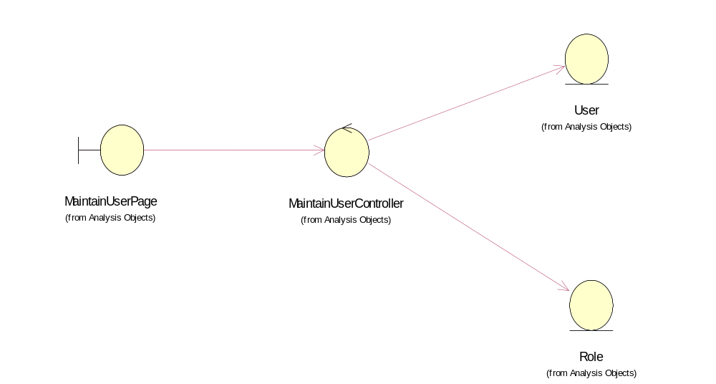

Derived Requirements
Portal Administrator and User Administrator have rights to access this page.

